4. birch

|  |  |
| --- | --- |
| Time limit | 1 second |
| Memory limit | 64Mb |
| Input | birch.in |
| Output | birch.out |

There is an old birch alley at the edge of the village. The alley is a straight W meters wide line. N birches grow along the left side of the alley, M birches grow along the right side. i birch from the left side grows at the distance of *ai* meters from the beginning of the alley, j birch from the right side grows at the distance of *bj* meters from the beginning of the alley.

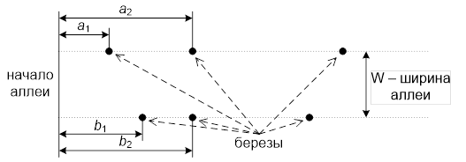

During summer vacation one young informatic identified that birchs’ barks were bitten by rabbits. The boy decided to surround trees with red stripes to protect them from rabbits (rabbits dislike red stripes and will not enter the surrounded territory). Unfortunately, he has only 1 L-meter long stripe, that he could not cut. The only thing he could do is to surround as many trees as it is possible. At the same time he needs to surround at least 1 tree on each side to protect the alley.

You need to create a program that will identify the maximum number of trees that can be surrounded by the given stripe according to the given length of the stripe, width of the alley and positions of trees on the alley. Assume that birches are dots, width of birches and width of the stripe make no difference.

Input format

First line of the input file contains 2 separated integers: length of the stripe and width of the alley (*1 ≤ L ≤ 2 × 105*, *1 ≤ W ≤ 104*).

Second and third lines describe birches along the left side of the alley. Second line contains number N — number of birches (*1 ≤ N ≤ 2000*), third line contains N different integers *a1, a2, …, aN*, that are set in ascending order (*0 ≤ ai ≤ 105*).

Fourth and fifth line describe birches along the right side. Fourth line contains number M — number of birches (*1 ≤ M ≤ 2000*), fifth line contains M different integers *b1, b2, …, bM*, that are set in ascending order (*0 ≤ bi ≤ 105*).

Output format

Output file has to contain one integer: the maximum number of trees that can be surrounded by the stripe.

It is guaranteed that if the maximum number of birches that is possible to be surrounded by the L-long stripe is equal to X, there is no way to surround (X + 1) birch by the stripe that is (*L + 10-5*) long.

Sample 1

| **Input** | **Output** |
| --- | --- |
| 18 4  3  0 3 6  4  0 3 6 10 | 5 |

Sample 2

| **Input** | **Output** |
| --- | --- |
| 5 3  1  0  1  0 | 0 |

Notes

In the first example it is possible to surround birches, for example, the following way.

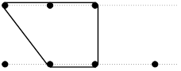

In the second example it is not possible to surround even 1 birch on each side.